**UNDERSTANDING DOCUMENT FOR Oauth2.0**

**Scope** – Which all details are needed ex : fn,ln,dp

**Authorization URL** – url where when yu login, request will be directed to this url and it gives auth code to rahulshettyacademy

**Client id** – generated when rahulshettyacaddemy registers with google

**Response Type** – what response you are expecting from google which is authentication code

**Redirection URL** – url which should be reidrected to after logging in google ie where google has to send yu back after authorization

**State** – Security purposes (optional) The state id for both rahulshettyacademy and google should be same.

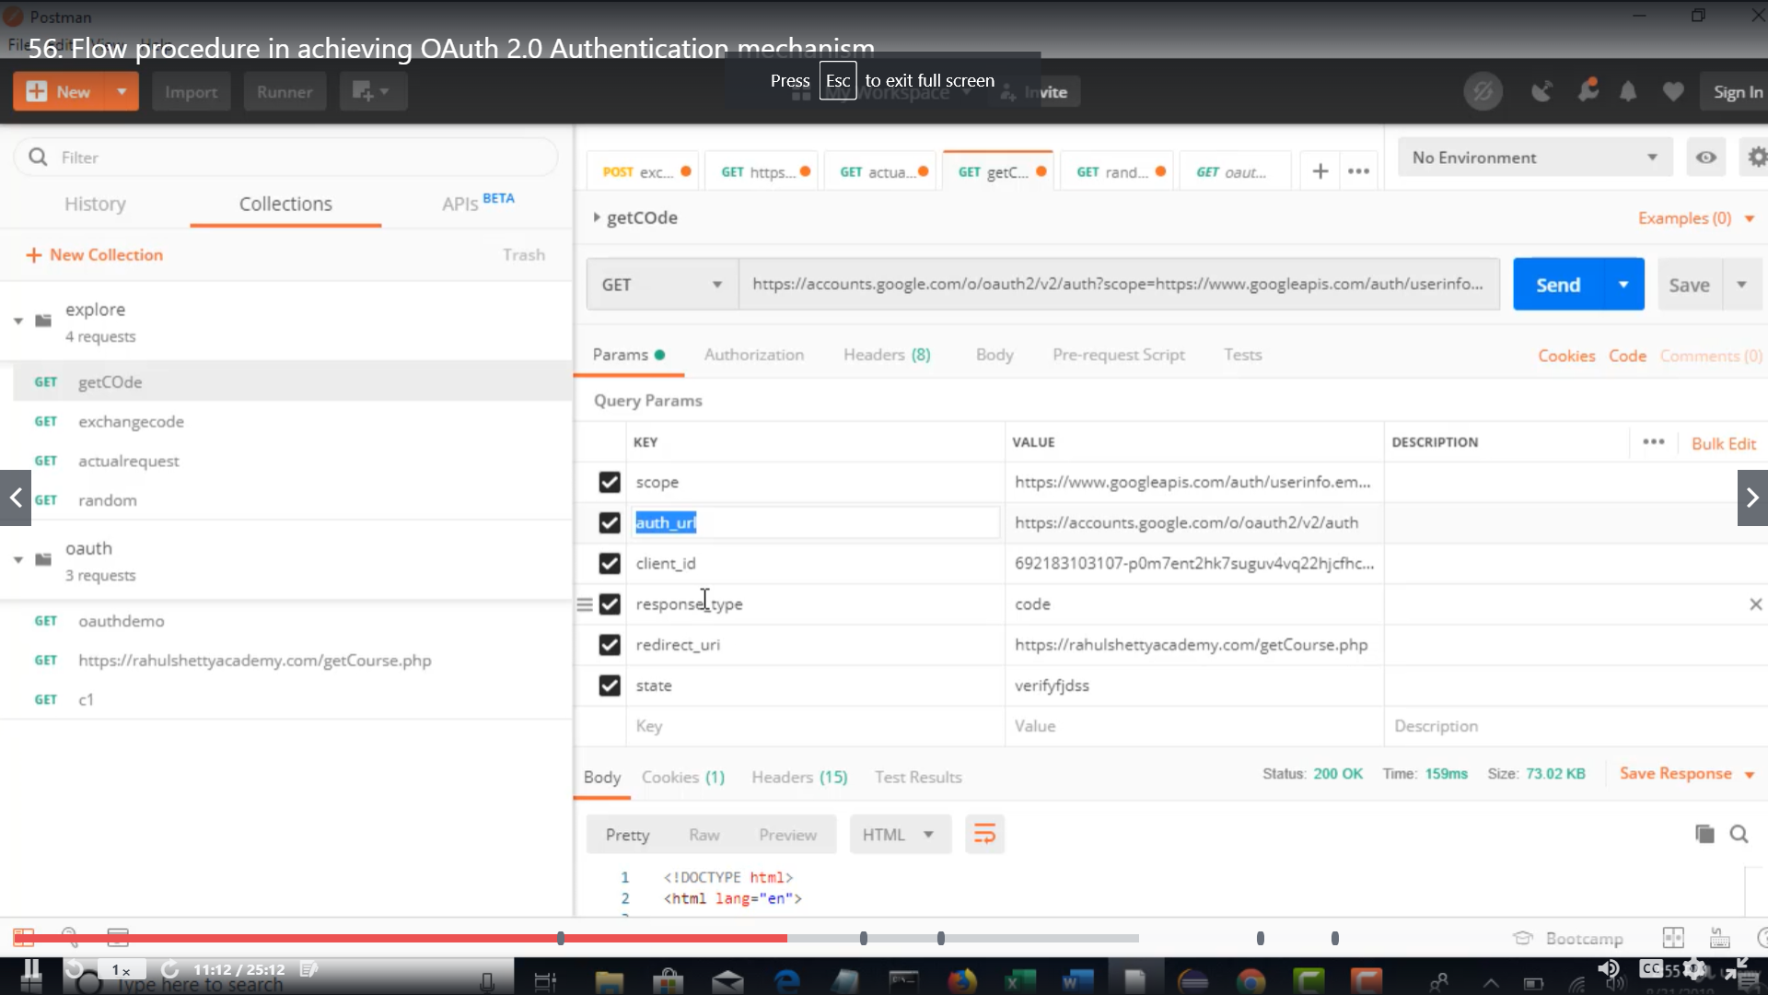

**getCode** – Signing in with the google credentials and getting the authorization code in the form of URL. After signing in, this shows

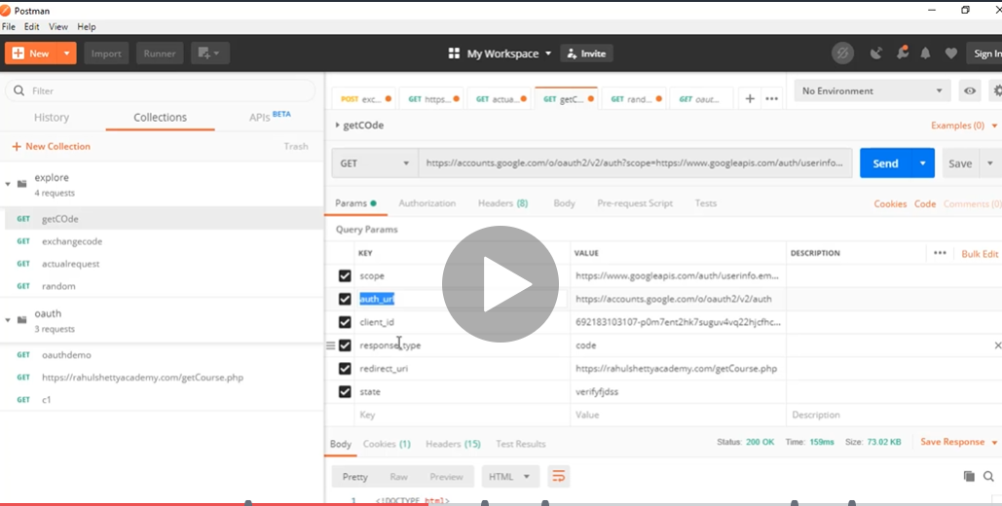

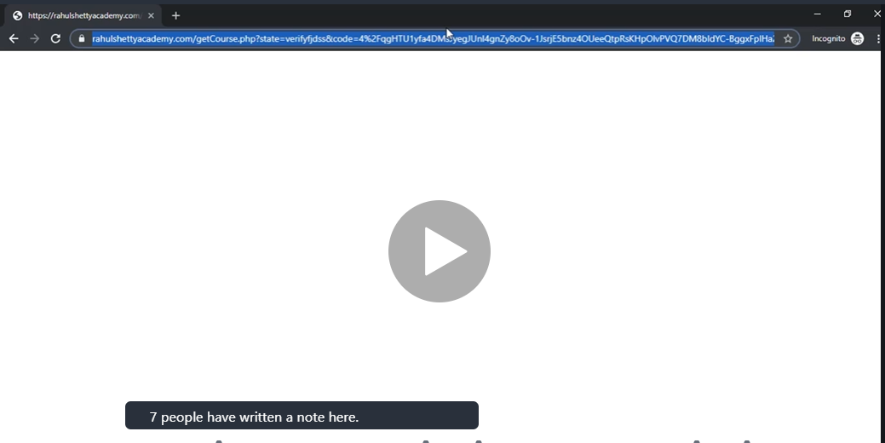

**random** – Authorization code will be there in the URL obtained above. Come to postman and paste it in the URL

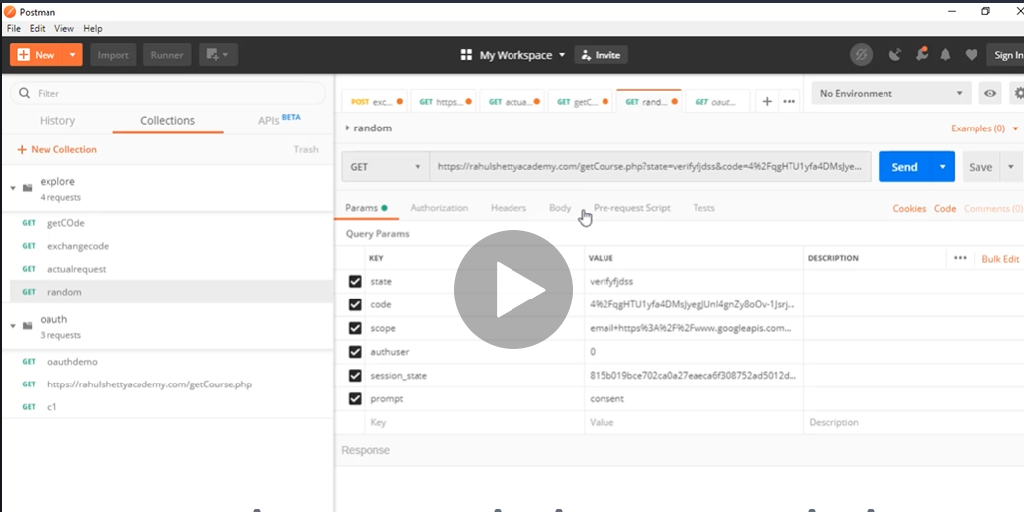

The code which is available in the query params is the Authentication code which was retreieved from the URL.

**exchangeCode –** This hits the resource server and gets the access token. The authorization code is sent with client id and client secret id to get the access token. The grant type is specified here as authorization type.

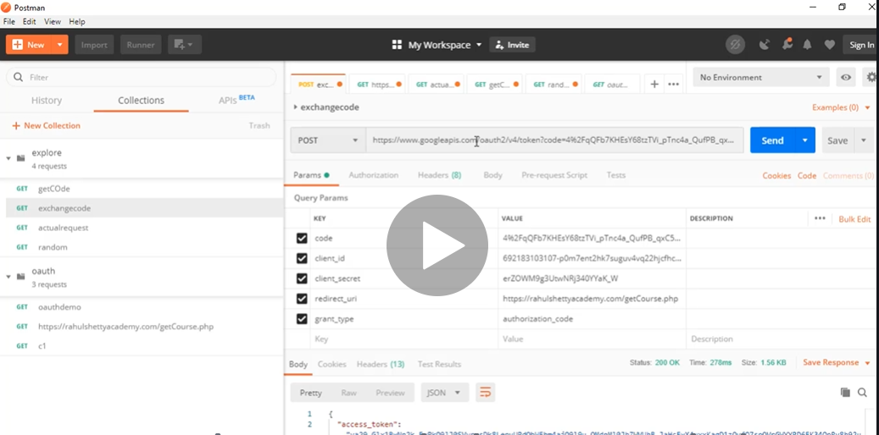

**actualRequest –** After login, the following page appears.

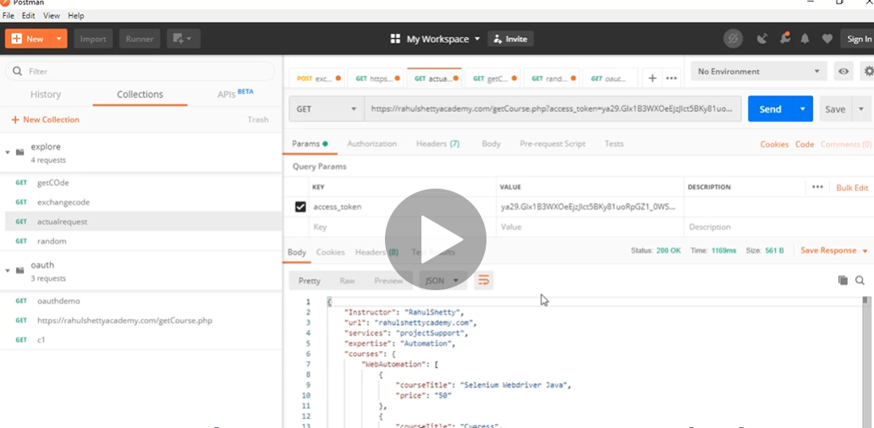

OAuth 2.0 Contract Details:

|  |  |
| --- | --- |
| **GrantType** | **Authorization code** |
| Authorization server url (getCode) | <https://accounts.google.com/o/oauth2/v2/auth> - To get the auth code. After logging in, google sends this auth code. |
| Redirect URL/Callback URL | <https://rahulshettyacademy.com/getCourse.php> - where should the site be directed after logging in google |
| Access token url (exchange code) | <https://www.googleapis.com/oauth2/v4/token> - We are exchanging the code to get access token. This is provided by Resource server |
| Client ID | 692183103107-p0m7ent2hk7suguv4vq22hjcfhcr43pj.apps.googleusercontent.com – Unique for application which is public |
| Client Secret | erZOWM9g3UtwNRj340YYaK_W - Unique for application which is private |
| Scope | <https://www.googleapis.com/auth/userinfo.email> - Which all info is needed |
| State | Any random string |
| How to pass oauth in request | Headers |

**Mandatory fields for GetAuthorization Code Request** ;

**End Point** : Authorization server url  
**Query Params**: Scope, Auth_url, client_id, response_type, redirect_uri  
  
**Output** : Code in the form of URL which Google authenticates and gives after entering the credentials

**Mandatory fields for GetAccessToken Request :**

**End point** : Access token url

**Query Params** : Code, client_id, client_secret, redirect_uri, grant_type

**Output** : Hit that URL and get the Access Token

//FOR CLIENT CREDENTIALS IT LOOKS LIKE THIS

